CHEF CHARITY EVENT EXCEEDS EXPECTATIONS
BostonChefs.com and Friends Raise $13,000+ for Second Chances
Cambridge, MA . . . (November 20, 2009) Two hundred plus foodies, followers of BostonChefs.com, and friends of Second Chances dined on autumn-inspired treats from some of the best eateries in Cambridge and Somerville at the sixth annual Flavors of Fall. In spite of worries that a weak economy and a political fundraiser that same night might depress turnout, the unique partnership between the beneficiary organization and event co-sponsors BostonChefs.com and City Square Associates yielded over $13,000 from ticket sales, community and corporate donations, and a silent auction.
In her remarks from the dance floor of a packed Regattabar, on Monday night, November 9, Second Chances CEO Andrea Shapiro praised the sponsors for their work in the community: “What you’ve all done for the past six years is huge. The commitment that you have shown to our community by supporting the work of Second Chances and five other local nonprofits is an amazing contribution to the people we serve and to all of us as community members.”
Paul Schiavone, president of BostonChefs.com, was high in his praise of the chefs who donate their time, talent, and food for the area’s best and longest-running autumn culinary extravaganza. “I’m always amazed by the creativity our chefs bring to this assignment. From spiced doughnuts stuffed with duck liver mousse to pumpkin whoopie pies, they’ve definitely figured out how to use the full spectrum of fall flavors!” Represented this year were: The Blue Room, Chez Henri, Garden at the Cellar, Gargoyles, Harvest, Henrietta’s Table, Hungry Mother, OM, Rialto, Sandrine’s, and UpStairs on the Square. “And we can’t forget The Charles Hotel who’ve been generous partners with us every year since we first proposed it to them back in 2004,” added Schiavone. “I can’t think of a better venue than Regattabar for a jazzy event like this.” The popular local Rollo Tomasi jazz ensemble provided the musical vibe for the evening.
Following the event, City Square Associates president Chris Schiavone reflected on the decision to focus on small community-based organizations: “The many large corporate non-profits in the Boston area obviously do great work, but they tend to have vast and established donor bases. What we’ve tried to do with Flavors of Fall is grow the resources and raise the profiles of micro-organizations that have macro-impact.” During this calendar year, Second Chances has provided free clothing, shoes and accessories for more than 400 individuals, and has collected over 75,000 pounds of clothing from the local community, preventing much of it from ending up in local landfills.
Since the first Flavors of Fall in 2004, over $60,000 has been raised for a wide range of Cambridge-based community organizations. Beneficiaries have used the proceeds to increase capacity, expand outreach, and evolve strategically.

THIS YEAR’S MENU
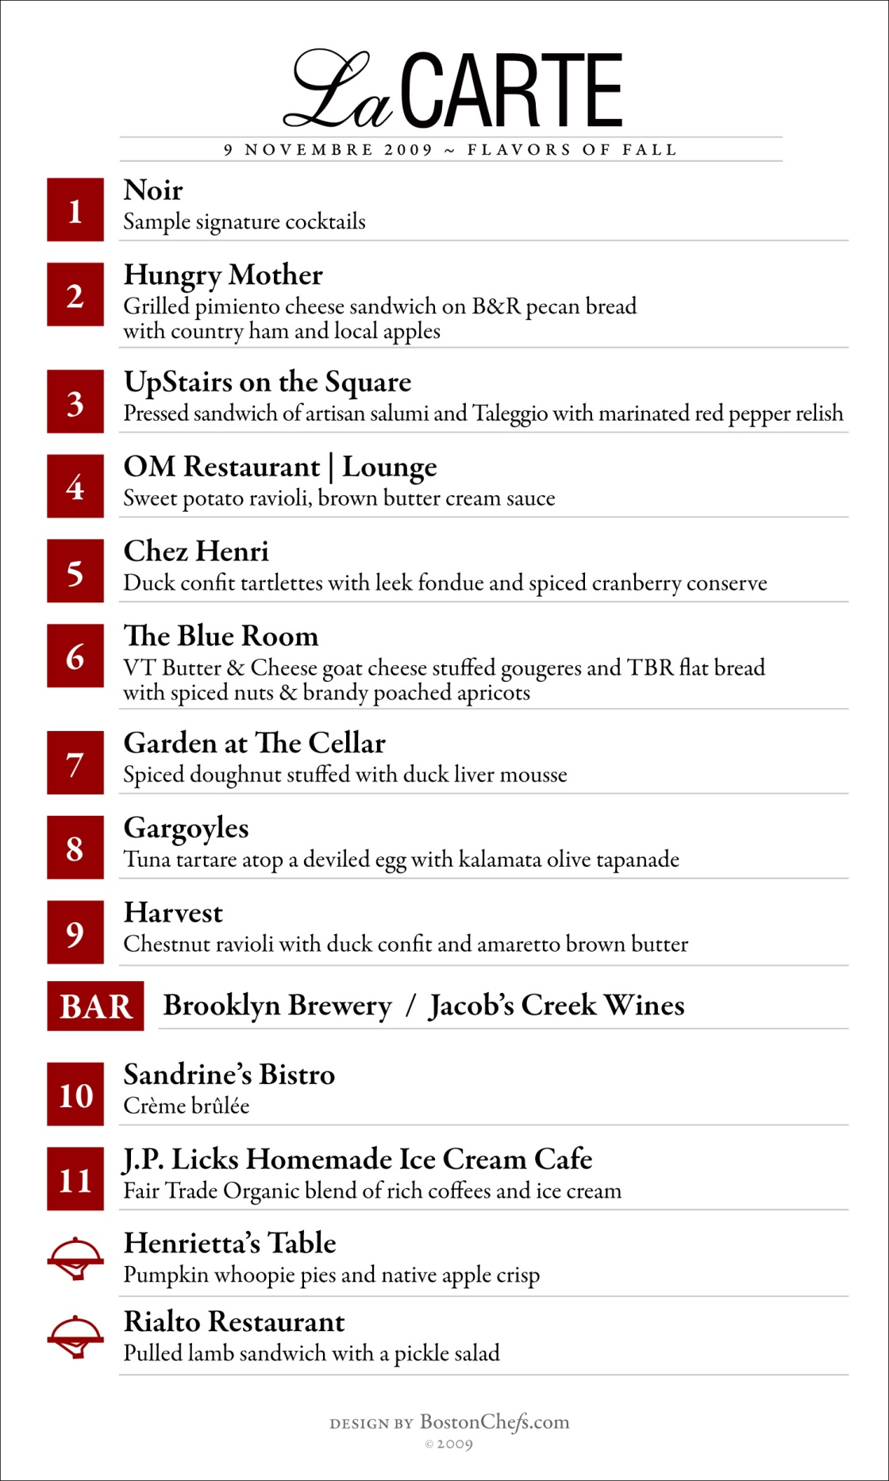

ABOUT THE PARTICIPANTS
BostonChefs.com is an online community of the area’s best dining destinations and top culinary talent. Boston’s own “Insider’s Guide to Dining,” features more than 125 of the best restaurants in Greater Boston and beyond. It provides comprehensive information on each dining destination—including menus, photos, chef bios, hours of operation, and restaurant background—and the most complete and up-to-date calendar of local food, wine and restaurant events available anywhere. BostonChefs.com is one of the most heavily trafficked and rapidly growing online dining destinations in the region.
Second Chances has provided free clothing to more than 1,500 lower income and homeless people in Cambridge and Somerville and recycled or reused over 145,000 pounds of clothing, shoes and accessories since 2005. With 100% donated labor and space, its clothing donation program helps local people in need, conserves natural resources, and diverts waste from our area's already overflowing landfills. Working closely with a growing network of partners, Second Chances involves the community in helping neighbors, connecting with other community members and preserving the environment.
City Square Associates, Inc. is a Cambridge-based marketing research and business consulting firm specializing in consumer behavior, public opinion, and media strategies. Over the course of a dozen years, City Square has developed a client roster that includes an impressive array of national brands—including NBC, PBS, Capital One, and Intuit—and non-profit organizations like the Pew Environment Group, the WGBH Educational Foundation and The Bridgespan Group.
The Charles Hotel, Harvard Square, is an independent luxury hotel and a member of Preferred Hotels and Resorts. The AAA Four-Diamond award-winner may be the only hotel in the world to welcome Noble Laureates, Pulitzer Prize winners, Academy Award winners, jazz greats and New England farmers. Reflecting the eclecticism that is Cambridge, The Charles Hotel is a modern interpretation of New England hospitality with a thriving jazz club, two signature restaurants, ice-skating rink, state of the art conference facilities and a central location in the heart of Harvard Square. The Charles has been designated by the New England Travel Guide as the best hotel to "stay put in" when visiting Boston.

